Mortgage Protection Life & Disability Insurance Sales with Leads
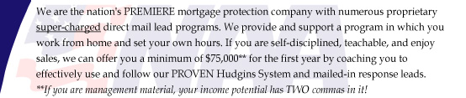
Description: Sell Life / Disability insurance to protect the homes of your clients in the event of death or disability. We provide and support a program in which you work from home and set your own hours. If you are self-disciplined, teachable, and enjoy sales, we can offer you a minimum income of $75,000 / first year by coaching you to effectively use and follow our PROVEN Hudgins System and mailed in response leads.
Full Time: $75,000 - $125,000 + residual income
Part Time: $40,000 - $$75,000 + residual income
Company PAID vacations to qualified agents
Products: Jet issue mortgage protection insurance, inexpensive term, universal life, final expense, annuities, disability and unique "MONEY BACK" term life insurance.
Leads: Direct mail leads, Best leads in the country, and our clients have NO DOUBT what they are responding to. Tired of prospecting and chasing lists? We focus our 80% of our time on the sales process vs. programs that emphasize time spent prospecting.
Selling System: Famous Hudgins System, If duplicated, guarantees a sale every time you sit down at an appointment.
Availability: There are very LIMITED openings due to our exclusive leads system. We limit the number of representatives in a determined area to insure maximum coverage and profitability of NAA representatives. The State requires or representatives to have a current Life & Health insurance license. If you are currently not licensed, you may still be eligible in this area for this opportunity and we will assist you in the easiest way to obtain this license.
More information: Visit our National web site at www.naaowens.com
For immediate consideration please call: 1-866-493-2845

